|  |
| --- |
| 3M Company |
| Getting Started with ETFS |
| Enterprise Team Foundation Server |

|  |
| --- |
| Mike O'Brien  Last Update: 1/7/2015 |

Contents

2 Introduction 2

3 What is TFS and ETFS? 2

4 What can I do with ETFS? 2

5 How to connect? 3

6 Source Control 7

7 Work Items 7

8 Reports 7

9 SharePoint portal site 7

10 Training 7

11 Moving onto ETFS? 7

12 Scrum – what’s that? 7

13 How can I get help? 7

13.1 Training 7

13.2 Support 7

13.3 Support Requests 8

13.4 Resolution 9

# Introduction

The ‘Getting Started with ETFS’ guide is a jump start document to get a person started and using ETFS quickly. Read through the guide, and use the ‘How do I get help?’ section to figure out your next step.

# What is TFS and ETFS?

**Team Foundation Server** (TFS) is a Microsoft product which provides source code management, reporting, requirements management, project management, automated builds, lab management, testing and release management capabilities.

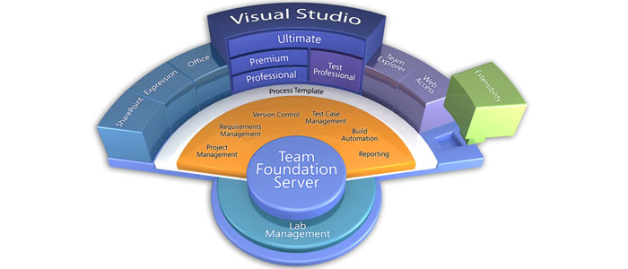

**Enterprise Team Foundation Server** (ETFS) is a highly available installation of Team Foundation Server for use by all 3M divisions and businesses. More information is available on the ETFS website at <http://tfs.mmm.com>.

# What can I do with ETFS?

ETFS is infrastructure that provides source control / revision control of project artifacts, requirements management, tracking progress to done, enables automated builds, automated testing, and release management capabilities.

If your team would benefit from any of these capabilities, then ETFS is of value.

# ETFS Environments

ETFS is made up of 3 primary environments.

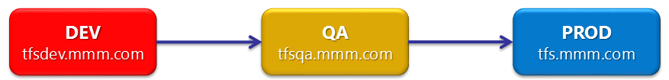

Contact you’re Project Administrator or Team Lead if unsure which environment to connect with. In general, if you’re looking to do Development tasks, check code in, perform a build, i.e., get work done, then PROD is where you want to be at.

DEV is used for refinement of a Team Project (process template), test new releases of TFS, prototype new sub-systems, etc. QA is used to make sure everything is working as expected before deployment to PROD.

If your still unsure, use the ‘How to get Help?’ section to contact the ETFS Team for assistance.

# How to connect?

ETFS is infrastructure – and has multiple methods for people to connect and interact with the system.

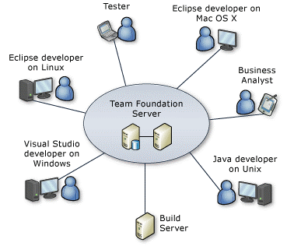

## Visual Studio

If you’re using Visual Studio, then the Visual Studio Team Explorer will work. First, make sure you have Team Explorer installed – you can tell from the ‘Help -> About’ dialog in Visual Studio.

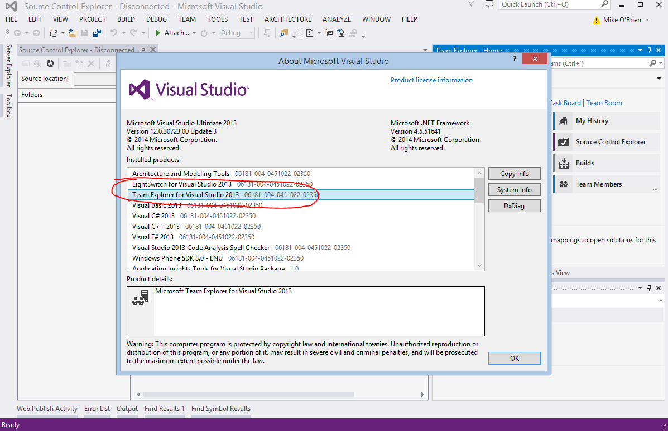

Team Explorer is installed with Visual Studio. If you need to install it, reach out using the ‘How do I get Help’ section. The screen shot above is from Visual Studio Ultimate. If you have Team Explorer installed, go to ‘Team -> Connect to Team Foundation Server’.

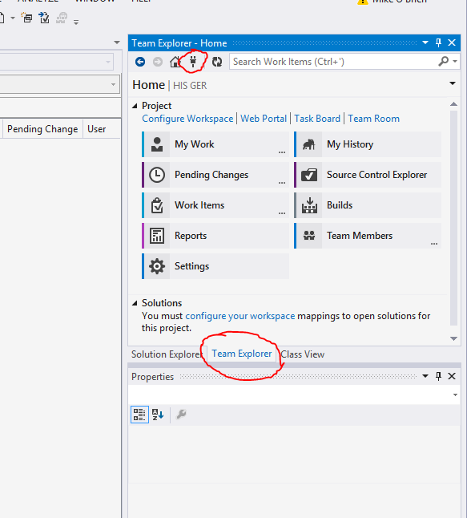

And Team Explorer will change to the below view:

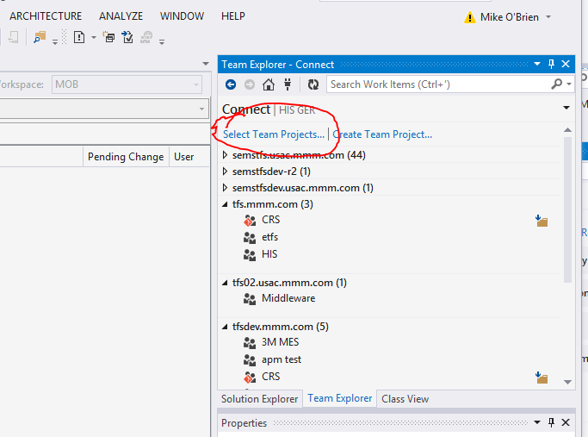

Click ‘Select Team Projects’ to add a server (your view could have no team projects listed).

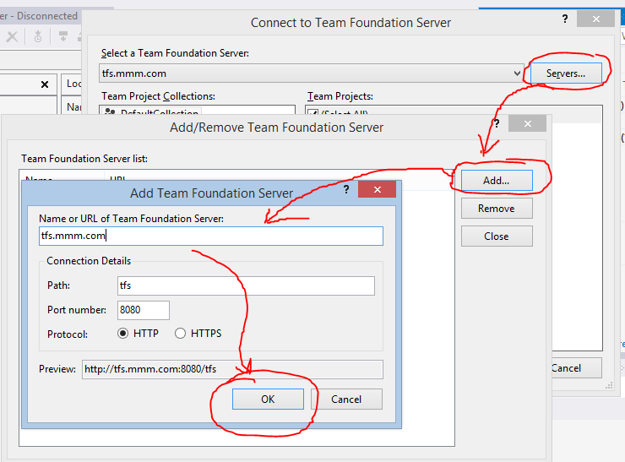

Then select the ‘Add’ button, and enter the ETFS server name into the text entry box. See the quick reference in the above section – ETFS Environments.

## Team Web Access (TWA)

You can bring up a web browser, and go to the environment url to login:

|  |  |
| --- | --- |
| Environment | Team Web Access URL |
| DEV | <http://tfsdev.mmm.com:8080/tfs> |
| QA | <http://tfsqa.mmm.com:8080/tfs> |
| PROD | <http://tfs.mmm.com:8080/tfs> |

This will bring up a web interface that’s equivalent in functionality to the Team Explorer in Visual Studio.

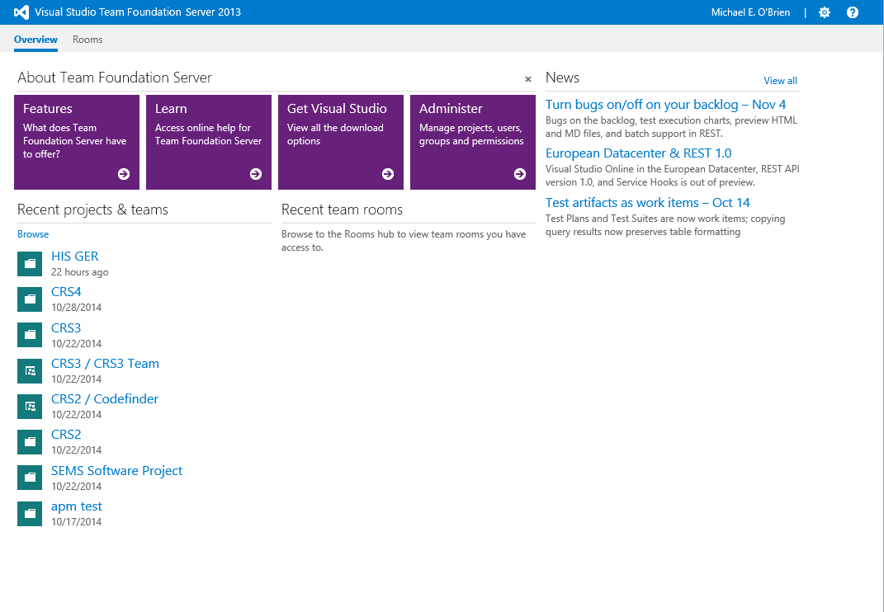

From here, find your Team Project using the ‘Browse’ link – this brings up a Team Project site page.

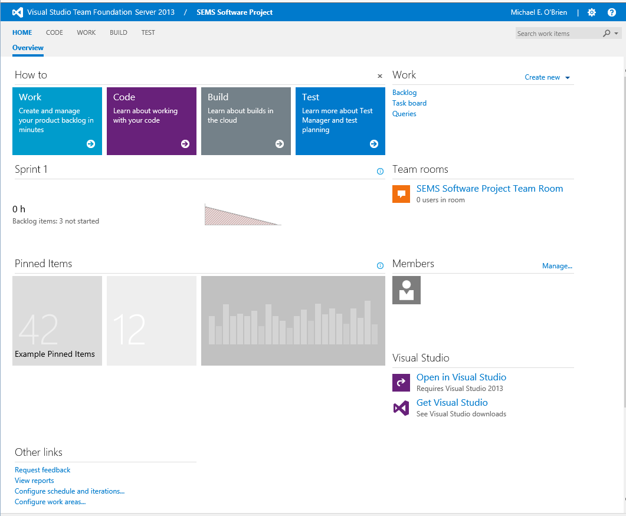

The links take you to the specific areas of interest – Code is source control, Work is for Work Item Tracking, Build is for the Team Build integration, and Test is for Test management (you may not see all of these depending on your licensing).

## Eclipse

If you have Eclipse, install the TFS Everywhere perspective and you’re connected. [Go here](http://msdn.microsoft.com/en-us/library/hh301122.aspx)[1] for detailed instructions from Microsoft.

# Source Control

## TFVC

Team Foundation Version Control (TFVC), aka, centralized version control is the first style of source control TFS supported. You can check-in, check-out, branch, search, see version history … all what you would expect from a source control system. Access this functionality with Visual Studio, Team Web Access (read-only), Eclipse, or with a command line from your work station.

Below is the quick screen shot to show the Source Control browser in Visual Studio – it’s a Windows Explorer style view. Right clicking on screen areas/nodes will give you options to do things, like get code, check out code, create a new folder, etc.

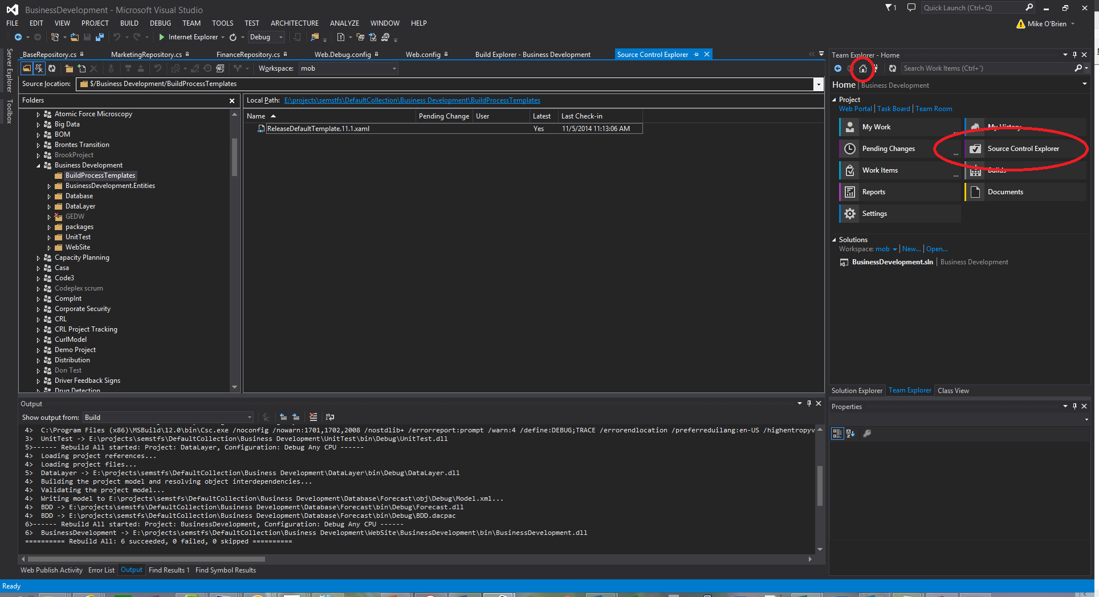

## Git

Git is the ‘new kid on the block’ within TFS, and was added in the 2012 release. If you already know Git, you know Git in ETFS. You can access Git similar to TFVC – using Visual Studio, TWA, Eclipse, or on a command line. Within Visual Studio, Git does not have a source browser within Visual Studio – but instead relies on the Team Explorer to push/pull/clone/branch, etc. Here’s one example.

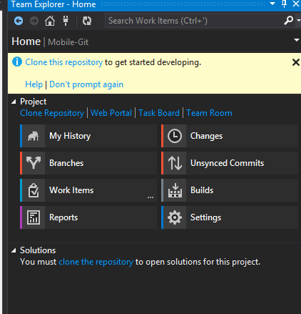

# Work Items

A Work Item in ETFS is what it sounds like – a unit of work. It’s an information container in the system – and you can create different types of Work Items. A bug, a Project Backlog Item, a Task – they’re all there. Using Work Items in ETFS, you can plan work using a Scrum process template, track progress, organize your work items requirements, etc. Below is an overview of an active Team Project.

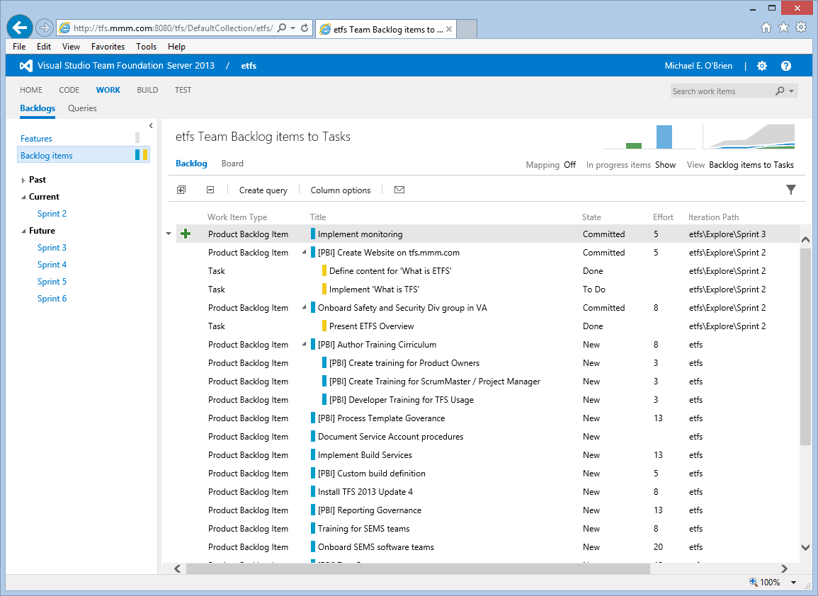

What follows is a quick ‘How do I do that?’ for the work items interface using Scrum – and the four ceremonies, i.e., Sprint Planning, Daily Standup, Sprint Review, and Retrospective.

## Sprint Planning

## Daily Standup

## Sprint Review

## Retrospective

# Team Build

Do you need a build machine to setup a nightly or continuous integration build for your team? Then Team Build is what you’re looking for. If you have a ‘really basic’ (.Net or Java) app with no 3rd party components, then the ETFS Build Farm may be for you. If you have 3rd party components (and they’re not free), then you’ll have to setup your own dedicated build machine. If you have needs to build iOS code, ETFS has that covered as well.

## ETFS Build Machine Farm

TBB – To Be Built – and written about.

## Dedicated Build Machine

Contact the ETFS Team to have your existing build machine added to the ETFS system. Keep in mind, a build machine can only be directed at one TFS system.

## iOS Builds

TBB – To Be Built – and documented.

# Reports

Reports currently are ‘out of the box’ from the process templates. You can see these reports either on your SharePoint portal for your team project (if you requested one), or go directly to the report server for your team project.

# SharePoint portal site

Each Team Project can also have a SharePoint portal linked with the Team project contents. A typical use would be as a project status page, and/or to organized documents from team members.

# Training

Training for ETFS is performed by the ETFS Team, and can be scheduled for your team. Visit the ETFS website at <http://tfs.mmm.com> and contact the team. Three training choices are available:

* Developer Training
* ScrumMaster / Project Manager / Product Owner Training
* Tester Training

# Moving onto ETFS?

# Scrum – what’s that?

# How can I get help?

## Support

To initiate a new support request, an ETFS user can call (651) 733-1000, or go [here](http://ithelp.mmm.com/Request.aspx?Id=CHBS-SR) on the IT Help website, and select ‘TFS’ from the application name.

## Resolution

If necessary, an Operations team member will contact the user to determine a resolution. When the issue is resolved, an email notification email is sent by the ITSM system.

Knowledge base articles will be written to encompass common support issues, and when possible, allow the operators to assist users directly.

1. Installing the Team Foundation Server Plug-in for Eclipse <http://msdn.microsoft.com/en-us/library/hh301122.aspx>